HTML tags are classified into two categories

1. Paired tags
2. Unpaired tags

**Paired tags:** These tags are having beginning and ending tags

**Example:**

<html>…</html>

<body>…</body>

<head>..</head>

**Unpaired tags:** These tags are individual tags. These tags are having beginning but does not have ending.

**Example:**

**<br>**

**<head>…</head>**

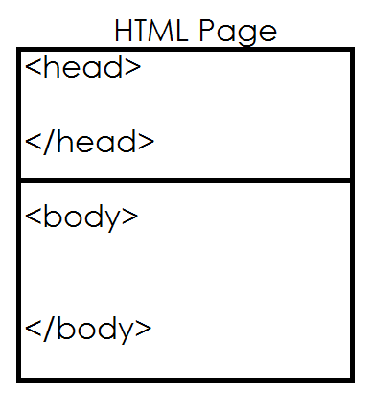

Head tag is used for defining metadata.

Data about data is called metadata.

Head is not displayed as part of web page or head is not displayed

Header contains,

1. Title
2. Styles
3. Script
4. Meta
5. Links
6. Fevicon

Download visual studio code from the following website

<https://code.visualstudio.com/download>

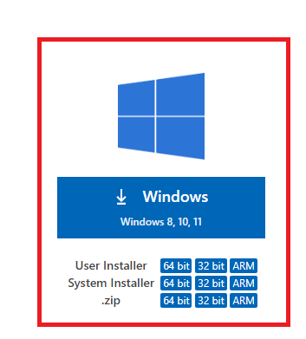

After installing VSCode

Add Extension

LiveServer

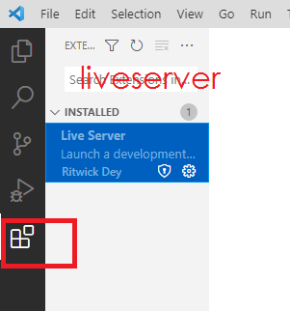

After developing webpage or web application, this web application is installed inside local server (live server). This server, serve web resources to client.

How to develop project in vscode?

1. Open vscode
2. Every project is one folder
3. Click Explorer
4. Open Folder
5. Create Folder
6. Select Folder
7. Inside folder create file with extension .html

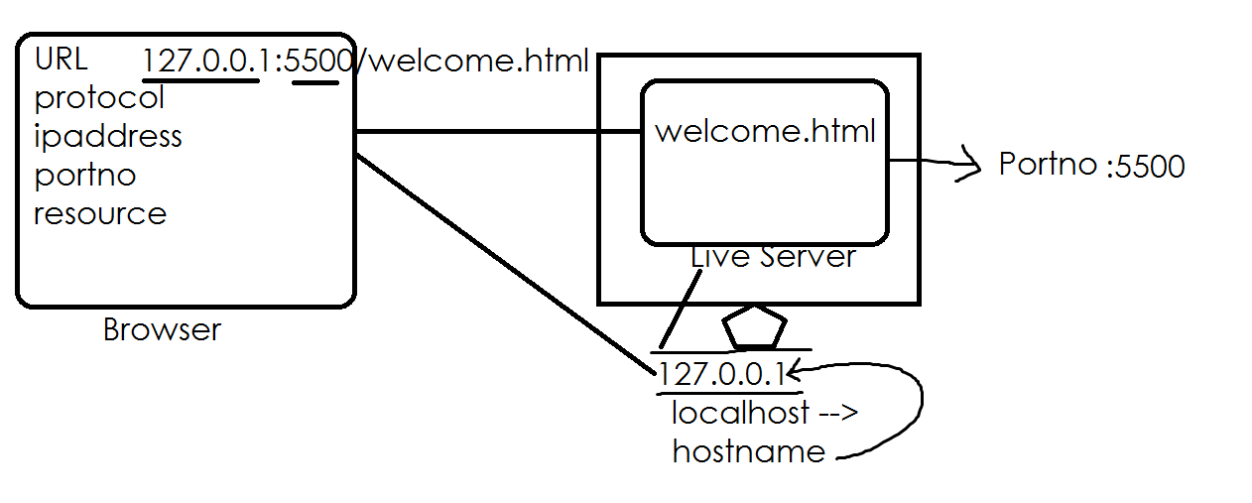

URL stands for Uniform Resource Location/Locator

1. Protocol
2. IPAddress
3. Portno
4. Resource

In internet always client communicate with server using HTTP protocol.

IPAddress of system where server is running

Portno is an integer number which is used to identify server program

Resource is a file or program for client send request